Experiment 11
Create a DataFrame of 10 rows and 4 columns with random values. Convert some values to NaN values. Highlight the NaN values.
import pandas as pd
import numpy as np
import webbrowser
import os

# Create DataFrame
np.random.seed(10)
df = pd.DataFrame(
np.random.randn(10, 5),
columns=['A', 'B', 'C', 'D', 'E']
)

# Convert some values to NaN
df.iloc[0,2] = np.nan
df.iloc[3,3] = np.nan
df.iloc[4,1] = np.nan
df.iloc[9,4] = np.nan

# Highlight NaN values
def highlight_nan(x):
if pd.isna(x):
return 'background-color:red'
return ''

styled = df.style.map(highlight_nan)

# Save HTML
file = "highlight_nan.html"
styled.to_html(file)

# Open automatically in browser
webbrowser.open('file://' + os.path.realpath(file))

print("HTML file created and opened successfully.")
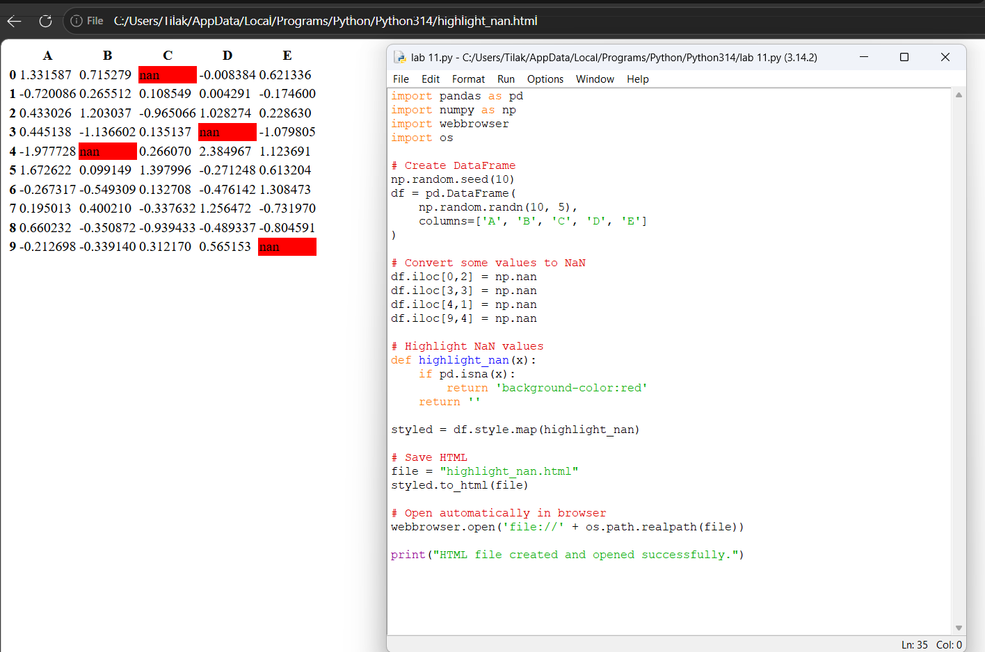

Experiment 12
Create a DataFrame of 10 rows and 4 columns with random values. Set DataFrame background color black and font color yellow.
import pandas as pd
import numpy as np
import webbrowser
import os

# Create DataFrame
np.random.seed(10)
df = pd.DataFrame(
np.random.randn(10, 5),
columns=['A', 'B', 'C', 'D', 'E']
)

# Apply style
styled = df.style.set_properties(**{
'background-color': 'black',
'color': 'yellow'
})

# Save HTML
file = "black_yellow.html"
styled.to_html(file)

# Open automatically
webbrowser.open('file://' + os.path.realpath(file))

print("HTML file created and opened successfully.")
